# High-Rise Mechanical Floor Fire & Smoke Simulation (FDS)

## 1. Problem Statement

Objective: To evaluate fire and smoke behavior in a high-rise mechanical floor under normal and fire-mode ventilation.  
Assessment includes temperature, airflow, smoke layer height, visibility, and jet fan performance.

## 2. Geometry & Assumptions

• Mechanical floor geometry imported from CAD  
• Ceiling height: 4 m  
• Inert wall and partition obstructions  
• SI units (meters, seconds, kg)

## 3. Fire Definition

• Design fire: 1 MW  
• HRR defined using ramp function  
• Burner modeled using block obstruction

## 4. Ventilation & Control Logic

• Jet fans modeled using vent pairs  
• Normal mode: 6 ACH  
• Fire mode: 10 ACH  
• Smoke detector-based activation

## 5. Mesh Details

• Cartesian mesh  
• Cell size selected based on domain and fire scale

## 6. Quantitative Results Plots

Plot 1: Peak Temperature (°C)

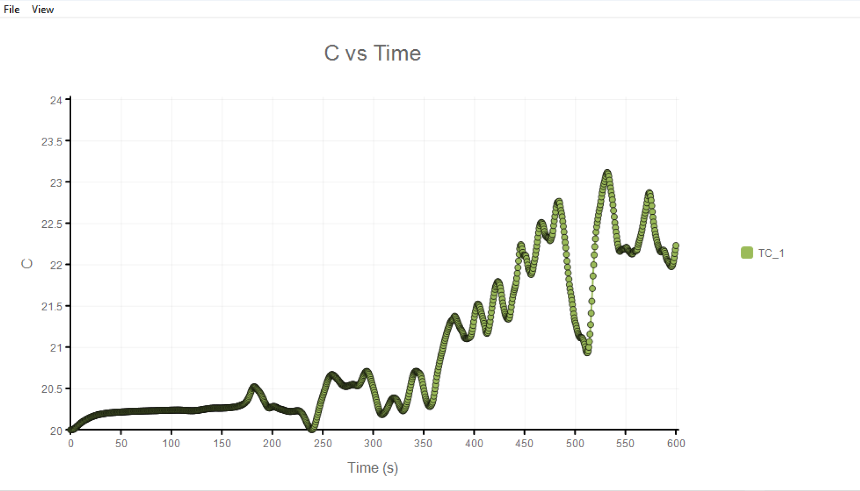 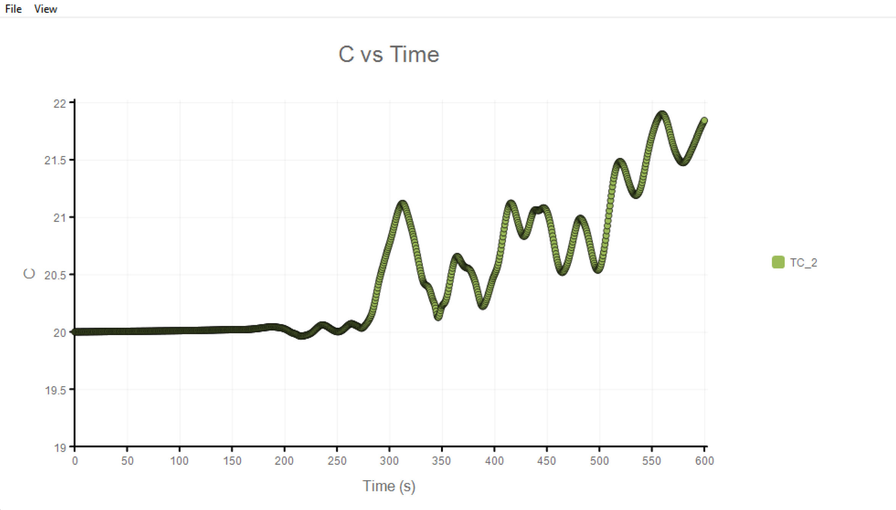

Plot 2: Average Velocity (m/s)

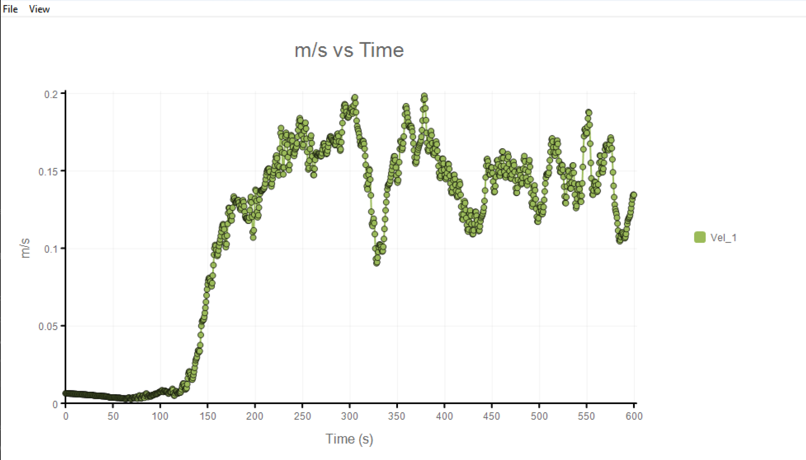 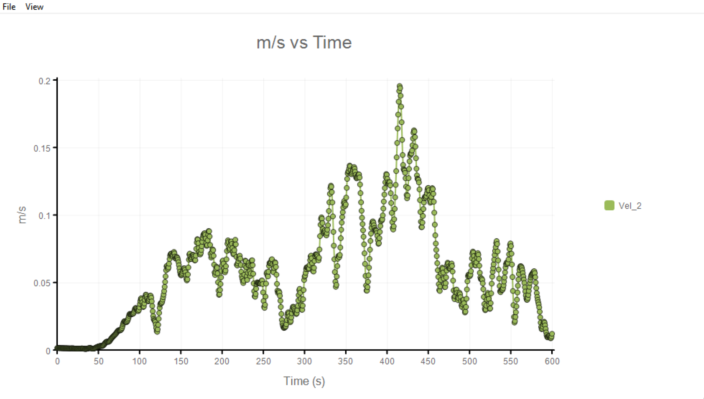

Plot 3: Heat Release Rate

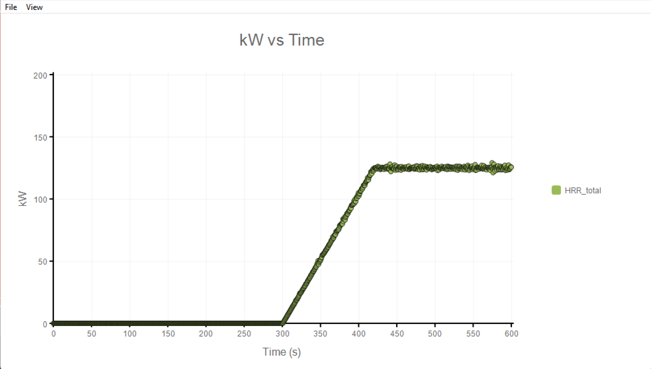 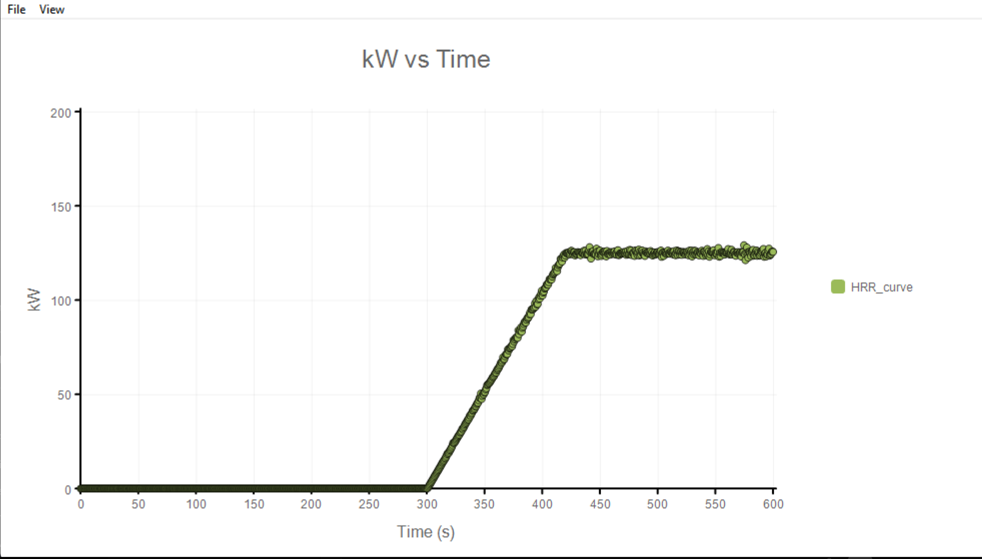

## 7. Figures

Figure 1: Temperature Slice

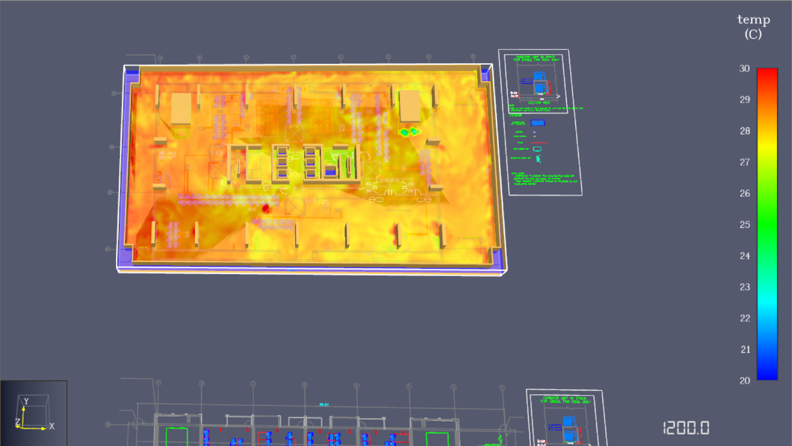

Figure 2: Velocity Slice

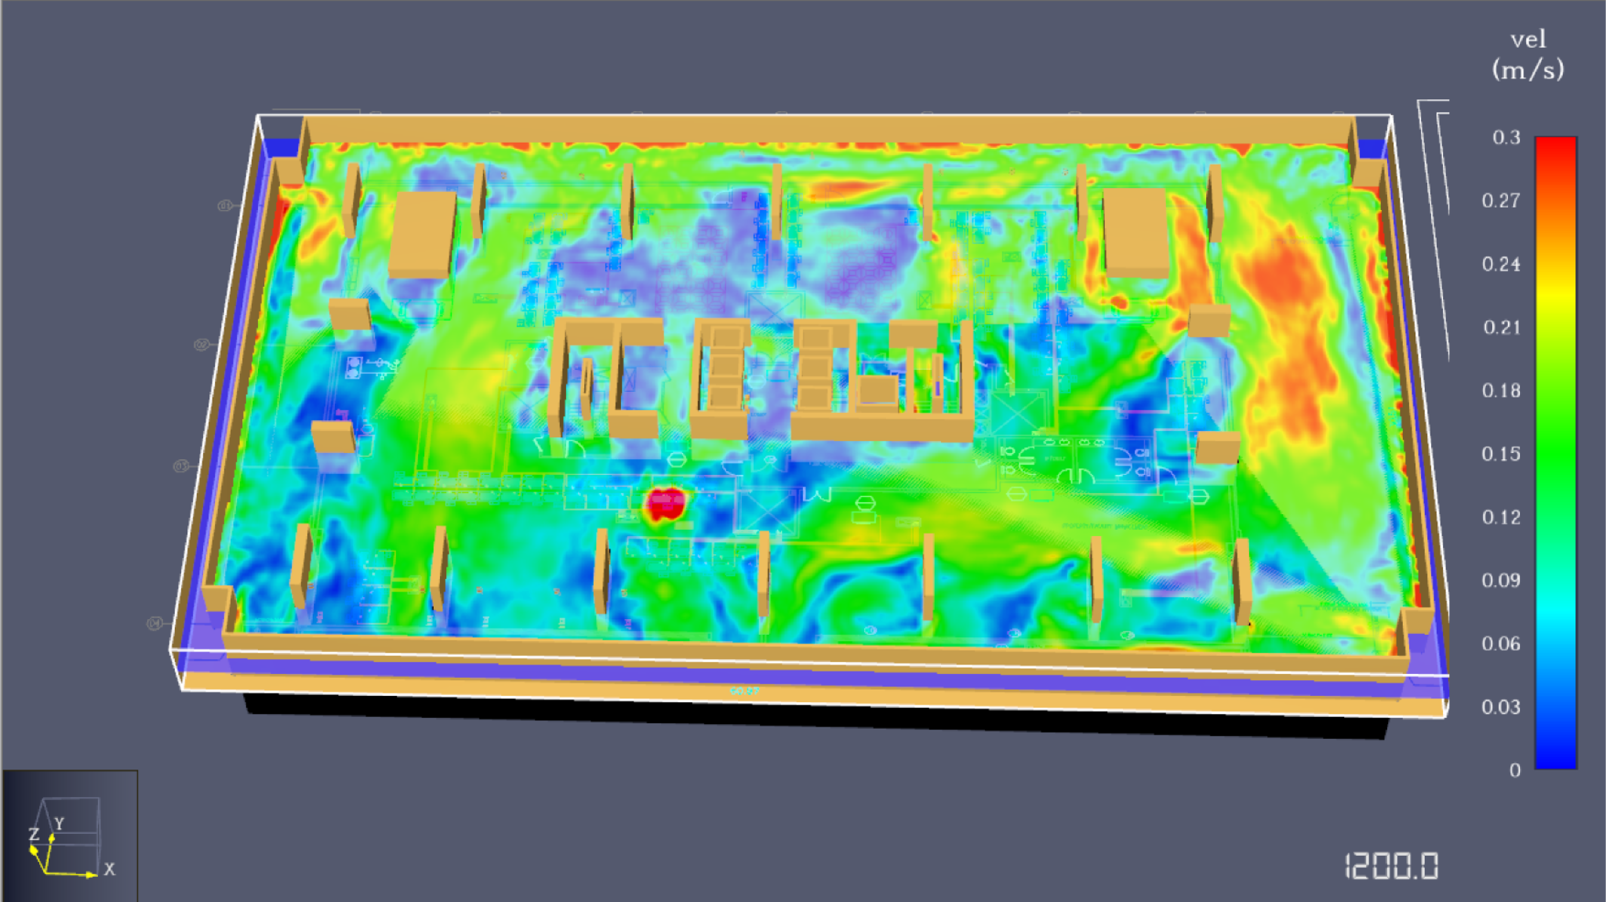

Figure 3: Soot Mass Reaction

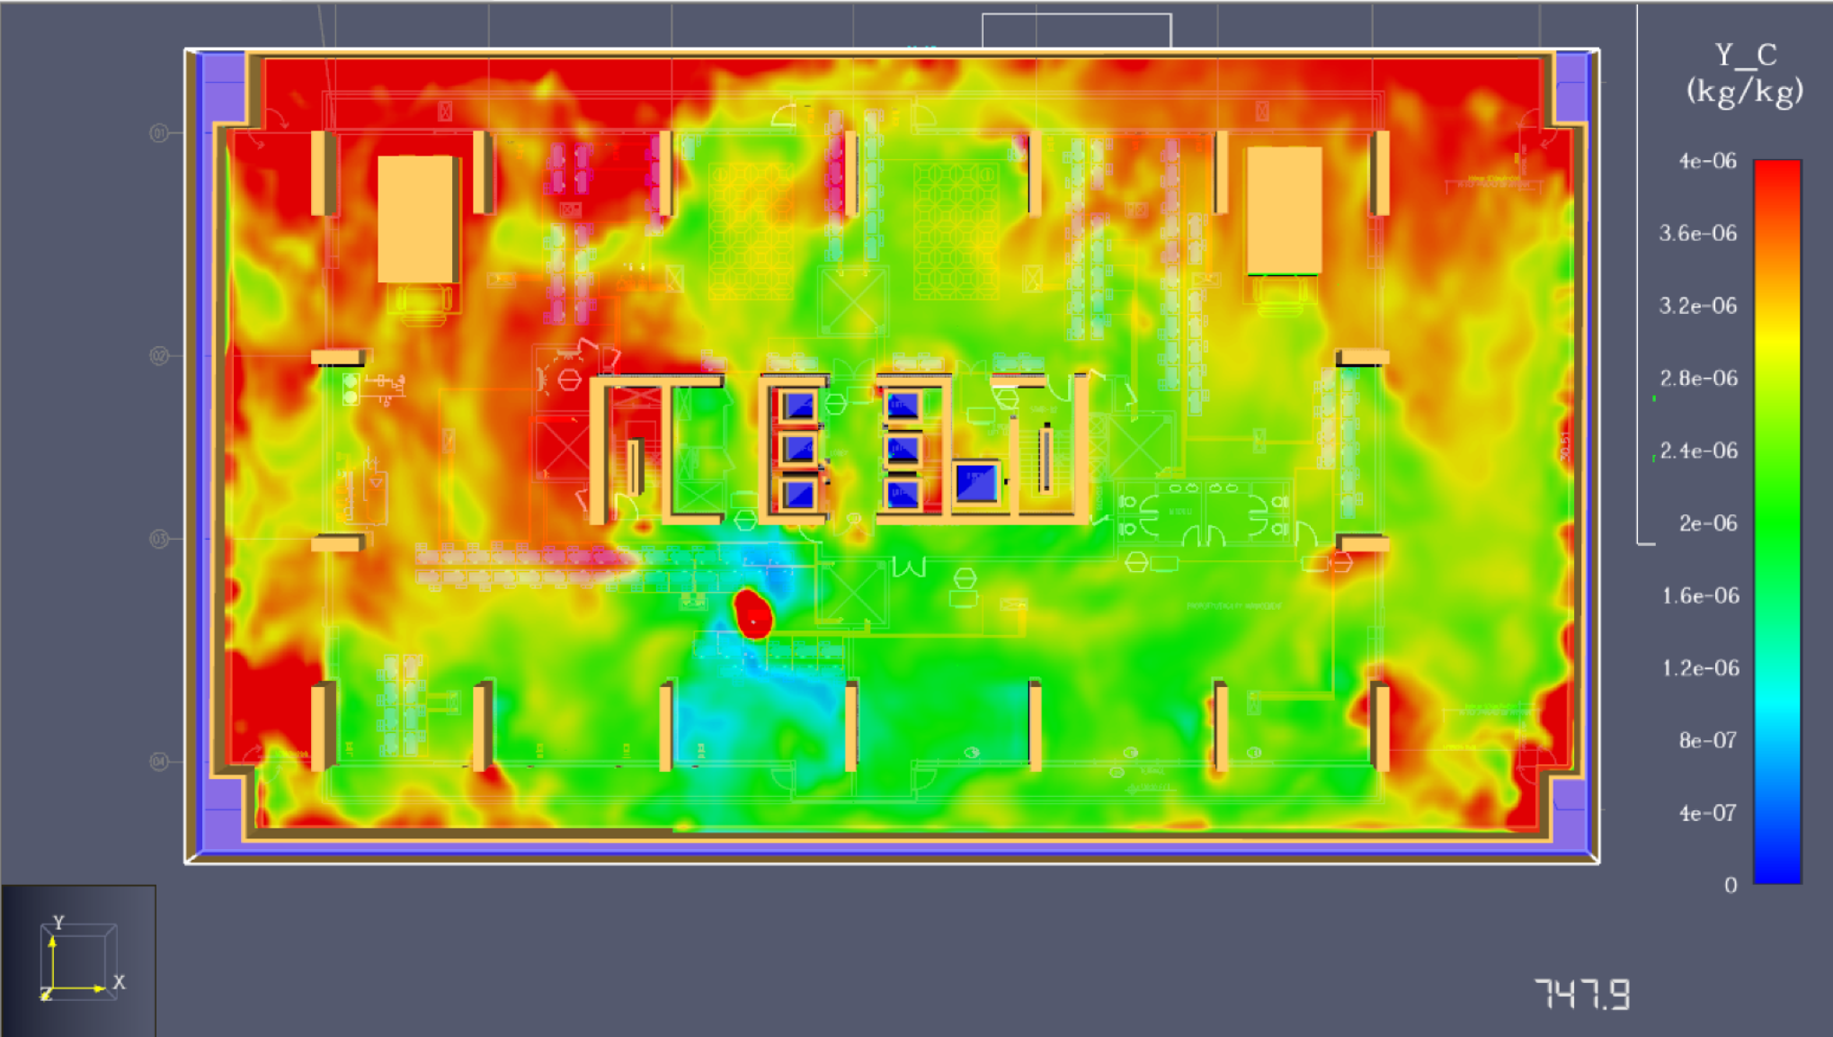

Figure 4: Visibility Contours

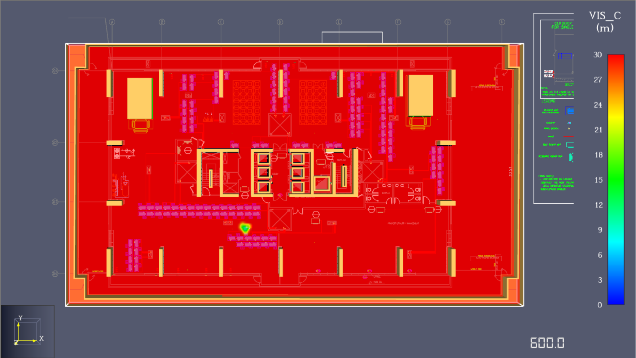

## 8. Conclusions

## • ****Temperature distribution with multiple condensing units operating simultaneously across the mechanical floors****

The temperature distribution across the mechanical floor remains largely uniform when multiple condensing units operate simultaneously, with localized temperature elevations observed in the immediate vicinity of the operating units. The 2D temperature slices at 1.6 m height show that bulk air temperatures remain close to ambient (approximately 20–22 °C) across most of the floor area.

Localized thermal plumes develop above and around the condensing units due to heat rejection; however, these plumes dissipate rapidly because of the large floor volume and continuous air movement induced by ventilation and jet fans. No significant temperature stratification or accumulation is observed, indicating that the ventilation strategy is effective in preventing heat buildup even under simultaneous operation of multiple units.

## • ****Average air velocity and velocity profile with multiple condensing units operating****

The average air velocity across the mechanical floor lies in the range of **0.05–0.15 m/s**, with localized peaks of up to **0.18–0.20 m/s** near jet fans and airflow discharge paths from condensing units. Velocity contour plots and point measurements indicate a non-uniform velocity profile characterized by higher velocities along fan-induced flow corridors and lower velocities in peripheral or obstructed regions.

The airflow pattern demonstrates effective momentum transfer across the space, ensuring air circulation throughout the mechanical floor. The observed velocity levels are sufficient to promote convective heat removal from the condensing units without generating excessive turbulence or stagnant zones.

## • ****Smoke layer height and smoke clearance efficiency using louvered wall design with jet fans at 6/10 ACH (normal/fire modes)****

During fire mode operation, with jet fans operating at **10 ACH** and louvered wall exhausts active, smoke is effectively diluted and transported toward the exhaust openings. Simulation results show that soot concentrations remain low at occupant level (1.6 m), and no distinct descending smoke layer forms within the simulated duration.

The effective smoke layer height remains close to the ceiling level, indicating good smoke clearance efficiency. Visibility at breathing height remains above 25–30 m for most of the domain, confirming that smoke is prevented from accumulating in occupied zones. In normal mode (6 ACH), ventilation maintains acceptable air quality; however, fire mode operation significantly enhances smoke removal and limits lateral smoke spread.

Overall, the louvered wall combined with jet fan operation provides an effective smoke management strategy across the mechanical floors.

## • ****Short concluding statement****

The CFD analysis confirms that the combined ventilation and jet fan strategy effectively manages thermal loads and smoke movement within the mechanical floors. The system maintains acceptable temperature levels, ensures sufficient air velocities, and provides efficient smoke clearance under both normal and fire operating conditions.